INDICES

$$*_{0}-virtual values$$

$$*_{r}-real values$$

$$*_{m}-desired impedance model$$

$$*_{p}-state of the manipulator plant$$

$$*_{0,p}-state of the virtual state of the plant$$

$$\hat{*_{p}}-estimated value$$

$$*_{im}-variables of the instantaneous impedance model$$

$$*_{d}-desired variables that are send to the inner controller$$

**DBIC**

Impedance equation $\left\{\begin{aligned}H\left(q\right)\ddot{q}+h\left(q,\dot{q}\right)=τ+J^{T}F_{int} \\ F_{int}=K\left(x_{o}-x_{r}\right)+B\left(\dot{x_{o}}-\dot{x_{r}}\right)-M\ddot{x_{r}}\end{aligned}\right.$

$$forward kinematics: x=L(q)$$

$$Jacobian: v=J(\dot{q})$$

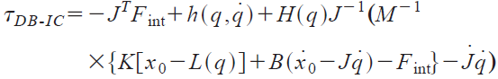

The resulting control law requires precise knowledge of the dynamic model and the parameter value.

DB-IC implicitly neglects the time delays induced by the controller and by the feedback loop, so it is not appropriate when the force or position change rapidly compared to those delays.

**PBIC**

$$F_{int}=K\left(x_{o}-x_{m}\right)+B\left(\dot{x_{o}}-\dot{x_{m}}\right)-M\ddot{x_{m}}$$

This method uses an inner position controller to track the reference trajectory of the impedance model.



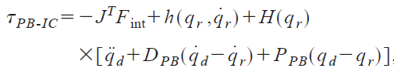

**IMIC**



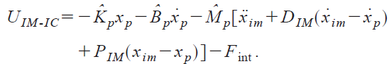

**Comparison**

|  |  |  |
| --- | --- | --- |
|  | DBIC | PBIC |
| Impedance  Tracking |  |  |
| Controller  Robustness |  |  |
| Accuracy  /Robustness | the sensitivity to errors in the damping or stiffness parameters depends on the desired impedance. | The natural frequency is increased.  The position of the eigenvalues increasingly drifts, thereby impeding the ability of the system to accurately track the desired impedance.  Thus, robustness is achieved at the expense of accurate impedance tracking— demonstrating the inherent accuracy/robustness dilemma of impedance control. |
|  |  |  |
|  |  |  |
|  |  |  |